**Design Document**

**Event website**

Made by:

Atanas Naydenov

Dimitar Markov

Dmitrii Orlov

Hristiqn Vasilev

**Content**

**Introduction**

The website is one of the major and most important parts of our system. It will be dedicated to a particular festival, organized by formal client‘s organization. It will serve for several purposes of event organization and management.

Its features will not only increase the reach of the event in social media, by that alone increasing the number of visitors, but also will contribute to creating a brand and establishing a certain level of presence of the events. This will result in rise of popularity and profit for formal client‘s organization.

Our goal was to create a website that will satisfy the needs and specifications of our system, be easily integrated with the database and possess the design with regard to reusability. Therefore, the product can be used as a template and will require only slight adjustments in order to be used for the future festivals organized by the client.

**Event Description**

The website, as well as all the other parts of our system, is optimized for the festival “Universe of Sound” for purposes of demonstration.

The main idea of the “Universe of Sound” is bringing the music lovers together: enthusiasts, independent artists, fans and people, who want to discover the world of music. Its purpose is to give visitors a chance to experience and understand its huge diversity. Thus, it does not focus on any genre or style in particular.

The event will include various activities for the attendees throughout the day. Those will be concerts and performances of different groups, workshops, lectures, lessons, interview sessions and presentations.

The festival will take place in a <nice epithet(s) to describe the venue> <place>. Every visitor will admire the beautiful starry night skies and will sure be delighted by the breathtaking surrounding nature.

“Universe of Sound” is a weekend festival and it lasts three days: Friday, Saturday and Sunday. Visitors will have an option to stay on the festival grounds by reserving a camping spot.

The festival will be organized relying on rules and terms that will ascertain the best and most fun visitor experience with no harm to the nature.

**The Target Audience**

The “Universe of Sound” targets people aged between 18 – 28 years. They might be students, independent artists and freelancers, young professionals, working either part-time or full-time.

According to various social and marketing research studies, attendees of this age group usually make up the largest part of most events’ audiences. Social membership does not matter a lot, but grading by income levels more representatives of not highly paid jobs is expected.

The scope of interests and views of visitors should include some of the following subjects: music and its history, art and especially its independent branch, self-development and healthy lifestyle, healthy fast foods, world cuisine, DIY, nature sustainability, travelling, and backpacking.

The design and event description featured on the website will attract the people described above and at the same time lower the possibility of high hooligans’ attendance levels.

**Sitemap**

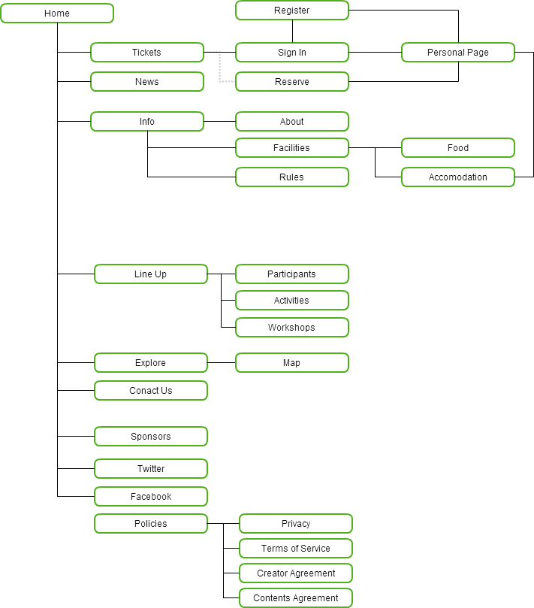

**Wireframes**